Assignment 6

7.5. If the sample size n is sufficiently large, then the population of all sample means is approximately normal.

7.7 a. 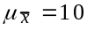
b.

c.
d.
7.11 a. Normal because the sample is large (n ≥ 30)
b.
c.
d. 1.43%; conclude that is less than 6.
7.16 a. np ≥ 5
n(1 – p) ≥ 5
b.

7.18 a. np = (100)(.4) = 40 : n(1–p) = (100)(.6) = 60: Yes, sample is large enough
b. np = (10)(.1) = 1 : n(1–p) = (10)(.9) = 9: No, sample is not large enough
c. np = (50)(.1) = 5 : n(1–p) = (50)(.9) = 45: Yes, sample is large enough
d. np = (400)(.8) = 320 : n(1–p) = (400)(.2) = 80: Yes, sample is large enough
e. np = (1000)(.98) = 980 : n(1–p) = (1000)(.02) = 20: Yes, sample is large enough
f. np = (400)(.99) = 396 : n(1–p) = (400)(.01) = 4: No, sample is not large enough

7.22 a.
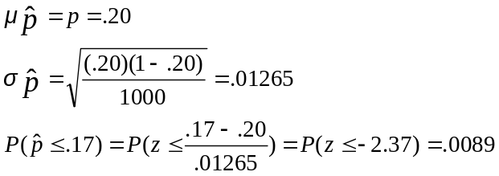

b. Yes, the probability of observing this sample is very small if p = .20. The true p is likely less than .20.

7.40 a.
b. Perhaps, but the evidence is not terribly strong

